MEMBERS OWING DEATH BENEFITS
(All listed below are beyond the 30 days)
As per the Bylaws-Article XIII-Section 6, a $5.00 assessment for each death is due to the Local Union
within 30 days of this notice.

Olakunle Awe – 2 | Tyler Baucher – 3 | Ryan Bickle – 1 | Benson Boughan – 1
Justin Bruns – 1 | Cameron Cimarolli – 2 | Aaron Deffenbaugh – 2 | Benjamin Dickrede – 3
Kevin Dicus – 3 | Aaron Dillard – 3 | Windell Dyer – 1 | Camron Earick – 1
Tyler Friesner – 1 | Benjamin Gambill – 2 | Jason Grace – 3 | Brandon Hodge – 2
Michael Johnson – 1 | Jordan Kaeck – 3 | Preston Laytart – 2 | Kenneth Long – 3
Greg McKenna – 1 | Grant McMichael – 2 | Kasiyah Morris – 1 | Morgan Mumaw – 1
Cole Myers – 1 | Blake Osborn – 3 | Brock Overholt – 1 | Austin Phalen – 3
Wyatt Place – 3 | David Ruppert – 4 | Zachariah Russell – 1 | Scott Scheid – 1
Tony Schubert – 3 | Ronald Schwartz – 1 | Bethany Slonaker – 1 | Derrick Smith – 3
Tanner Smith – 1 | Matthew Sterrett – 1 | Robert Stonehill – 1 | Mason Streby – 3
Nathaniel Swaney – 1 | Samantha Swaney – 2 | Spencer Williams – 2 | Cole Wilt – 3
Dale Woods – 1

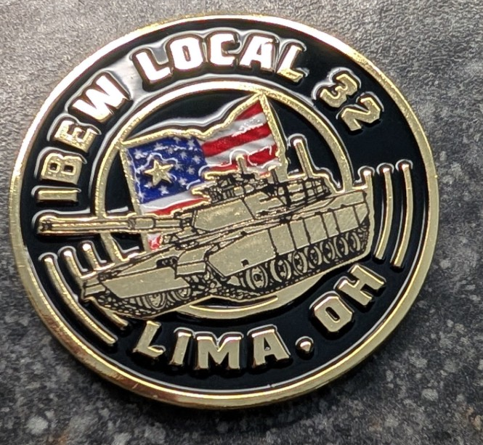
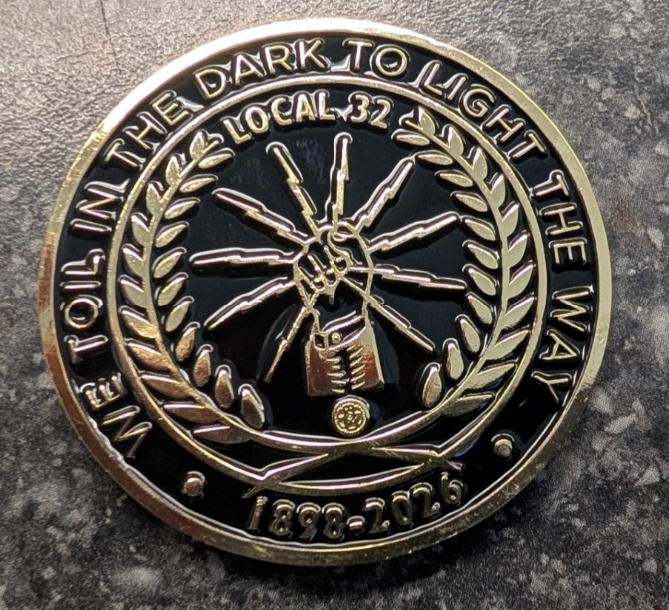
Just in! New Challenge Coins!
Just $12.00 each!

