THERE ARE NO DEATH BENEFITS BEHIND! (WOOO HOOO)
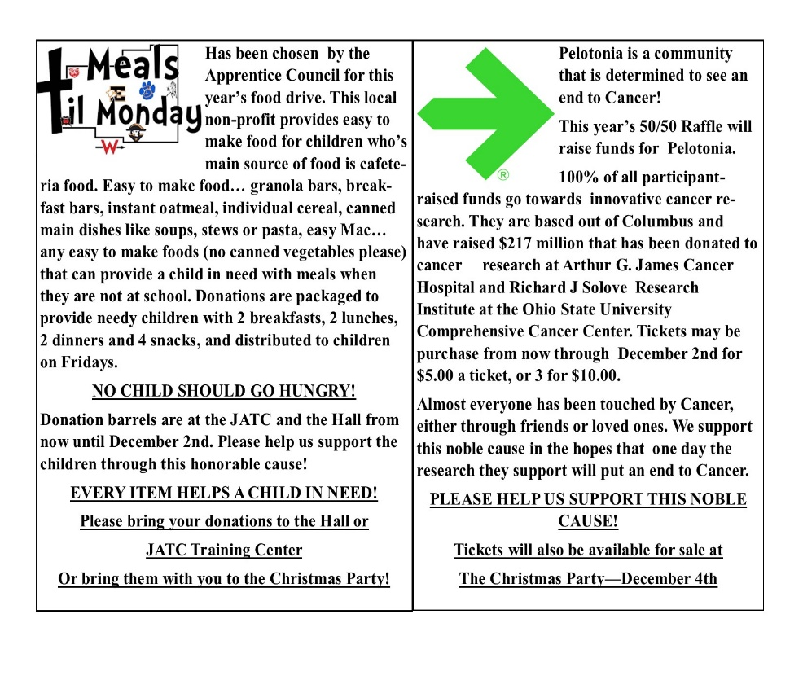

RESIGNS ARE EVERY MONTH
BETWEEN THE 10TH & 16TH

***IF YOU SIGN THE BOOK ANYTIME BEFORE THE 10TH OF THE MONTH, YOU MUST RESIGN FOR THAT MONTH (EVEN ON THE 9TH)

