PAID THROUGH  April 2021  Tyler Baucher  Tyler Baxter  Robert Buckland  Devin Casemier  Tony Childs  Ryan Conley  Shane Falke  Jon Green  Robert Hartings  Kenneth Long  Jeffrey Metzger  Kent Miller  Jason Miller  Jacob Otto  Stanley Parsons  Logan Rex  Heath Rider  Lucas Schroeder  Derek Sterling  Samantha Swaney  Nathaniel Swaney  PAID THROUGH  March 2021  Tracy Dukes  Cody Evans  Joe Hardesty  Danny Keen  Stephen Landwehr  Brandon Miller  Stephen Nichols  Todd Rosebrook  Gregg Sharp  Eric Vogt  Nathaniel White  Cameron Wireman | PAID THROUGH  February 2021  Matthew Boedicker  J Boedicker  Doug Cantrell  Scott Hochstetler  Gail Jackson  Vince Scheid  PAID THROUGH  January 2021  Kevin Dicus  John Harter  Shanon Hauenstein  PAID THROUGH  December 2020  Randy Hoersten  Timothy Marlatt  PAID THROUGH  November 2020  Jonathon Glassford  Aaron Quinton  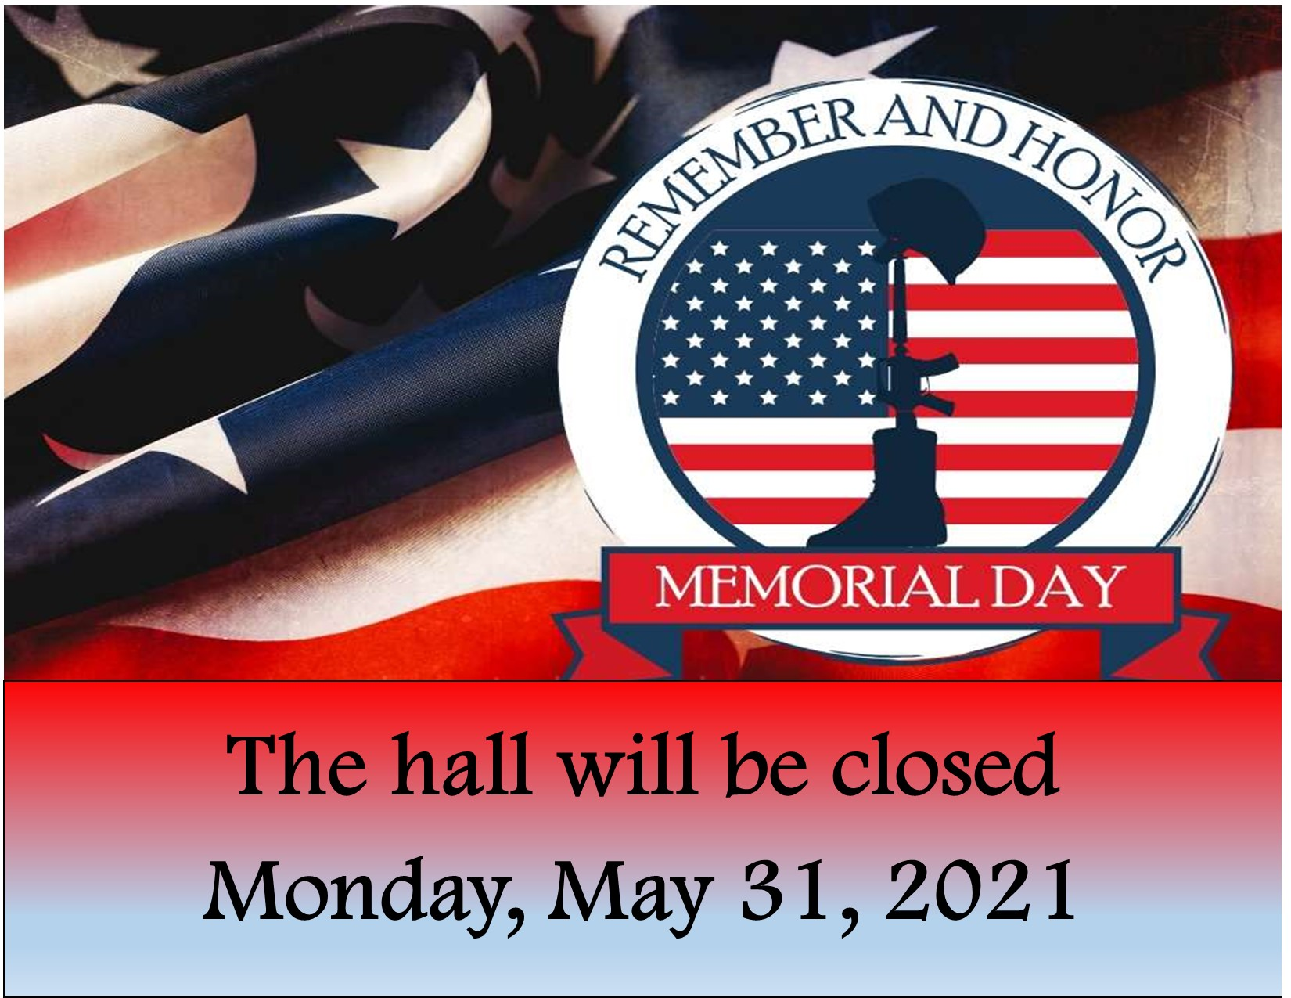  Training Director’s Report  We are proud to announce the Graduation of 6 IBEW Local 32 Apprentices! Through these unusual times, they persevered. Congratulations new Journeymen! YOU DID IT!!!  I am currently in the process of setting up First Aid/CPR classes for next month. I do not have a definite date yet, so call the training center, the hall, or check the IBEW 32 website for more details. We hope to see you there!  We are excited to announce a special 2-day Workshop at Lima JATC Training Venter September 17th – 18th, 2021. The new 2020 National Electrical Code contains significant changes that will impact how you do your job. Stallcup’s Illustrated Code Changes 2020 will combine lecture, workbook, and visual aid for the most effective training available. A $500.00 participation award will be given to those who attend all 16 hours, and you will be gifted with the new code book to keep!  Again, if you have any thoughts or ideas or classes, please let me know.

We currently have an opening on the
Exam Board
Please send Letter of Interest to the hall no later than June 14, 2021.
The Ole’ Guys

May is here and we are happy with it. We had a real nice day Wednesday. We talked a lot about old age and how we are all having old age and all the pain that goes with it. We were surprised that we about all have the same things going on. Most of us have been to a Dr, somewhere for the aches and pains.

The meeting is the second Wednesday of the month at 2:00PM at the Union hall, all the retirees are welcome and we hope more of you can come.
Things to think about:

If a turtle doesn’t have a shell, is he homeless or naked?

Why don’t sheep shrink when it rains?

Never underestimate the power of stupid people in large groups-

Age is a very high price to pay for maturity.

And finally:

Woman like silent men, they think they’re listening.

R. S.

Jim Hoskins

